The Following are the tables has to be in your database & model deisgn:
users
codekata
attendance
topics
tasks
company_drives
mentors
students_activated_courses
courses

The following are the queries need to be executed
1. Create tables for the above list given
Answer:
Created ‘mysqltask1’ Database.
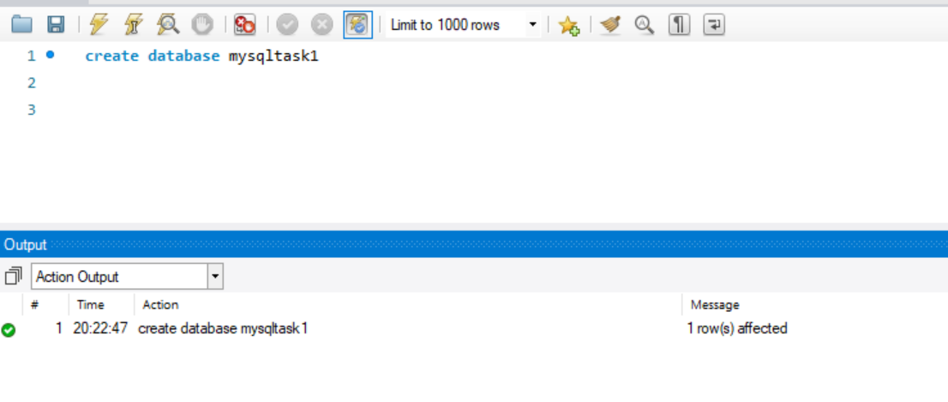
Users:
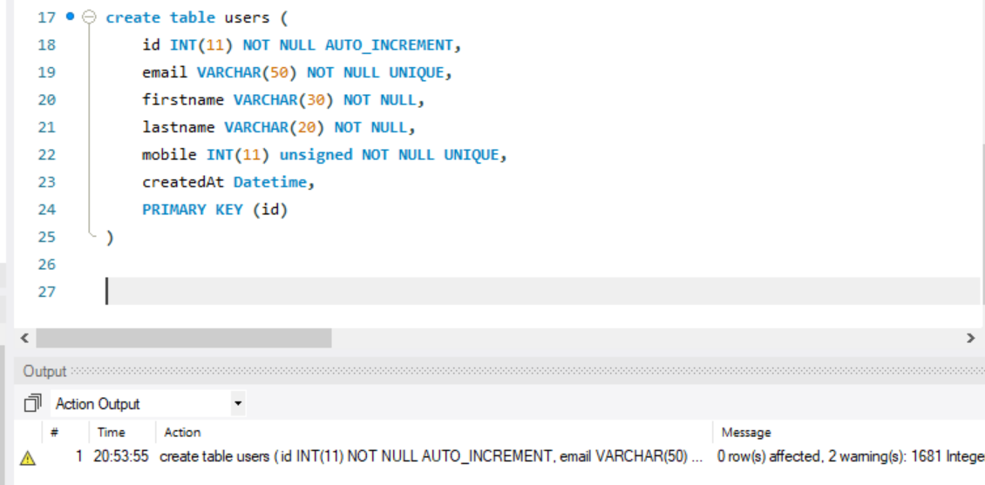

Codekata:
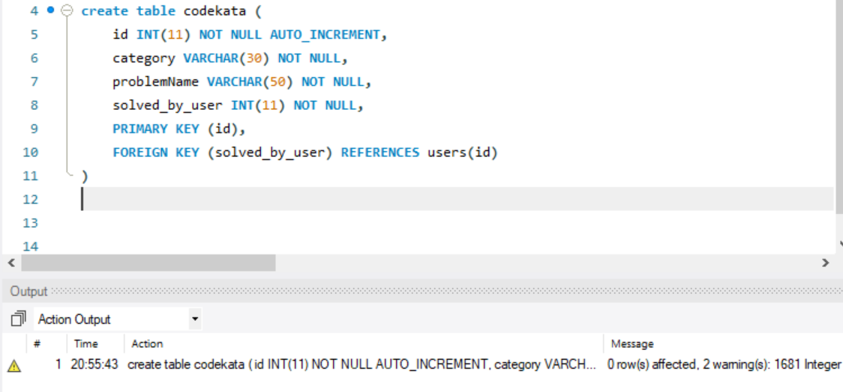
Attendance:
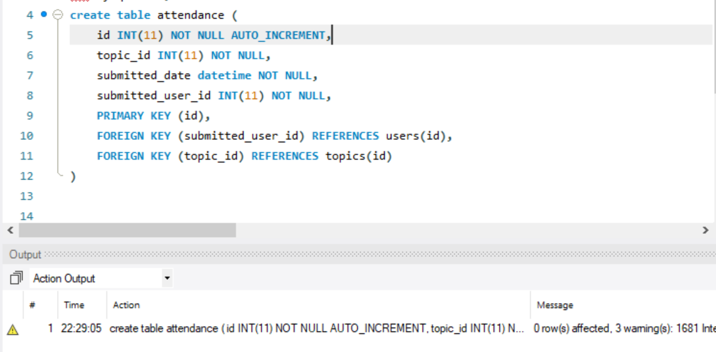

Topics:
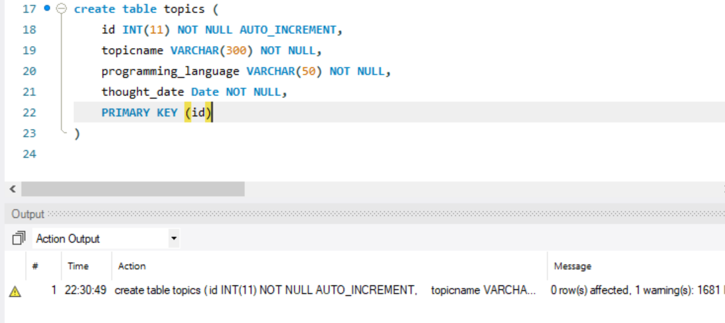

Tasks:
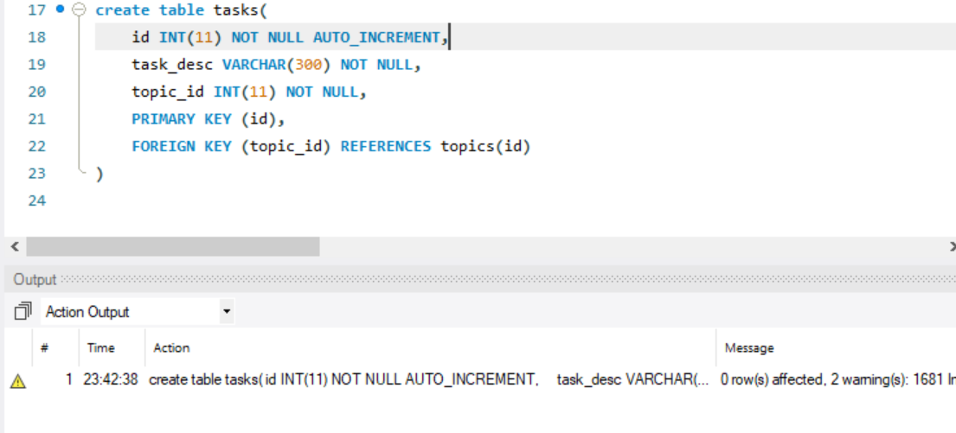

Company drives:
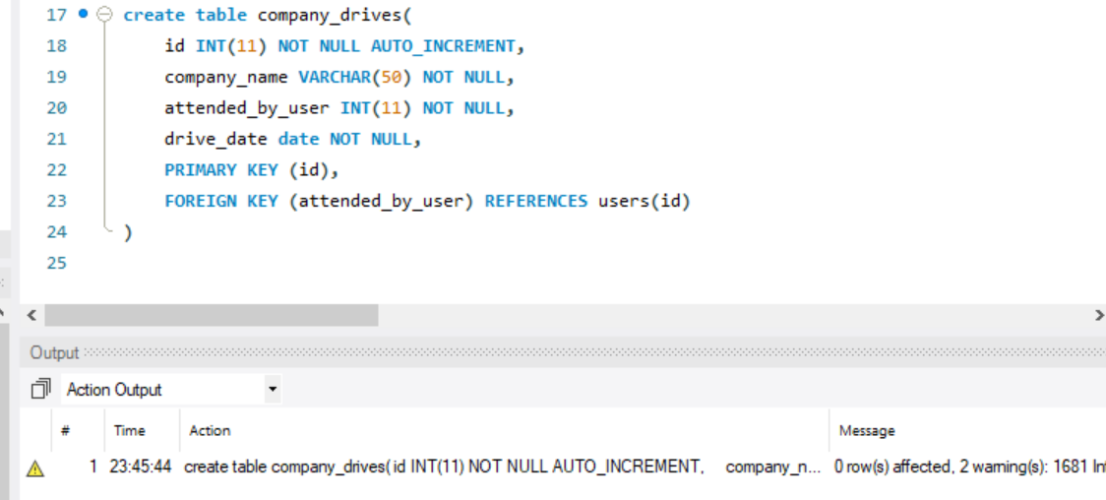

Mentors:
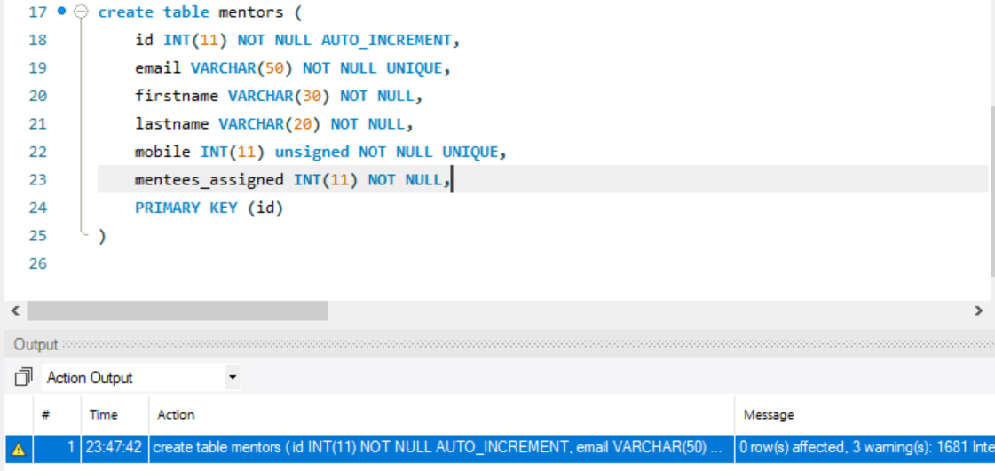

Students activated courses:
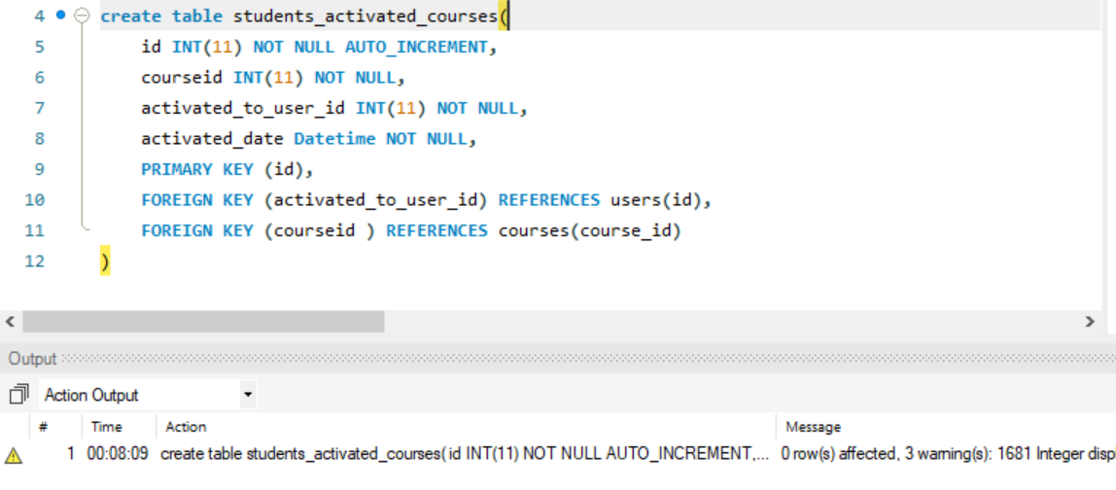

Courses:
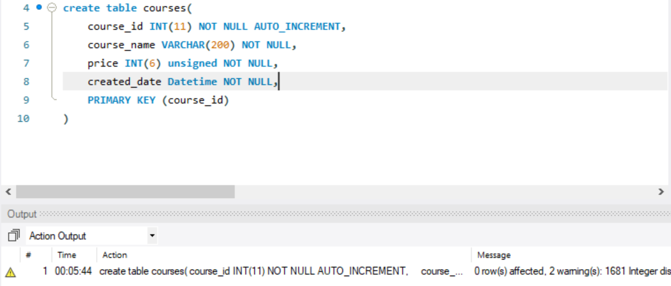
2. insert at least 5 rows of values in each table
Answer:
Users:
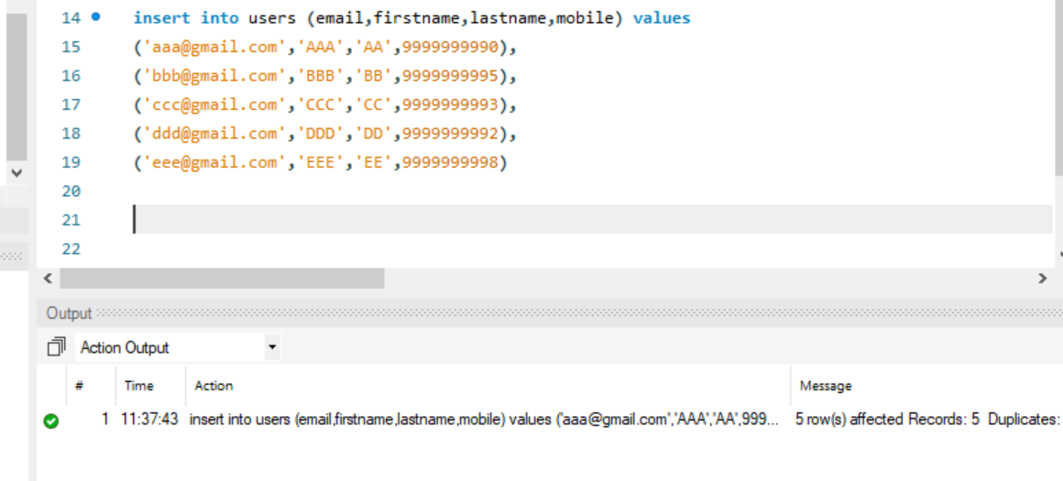

Codekata:
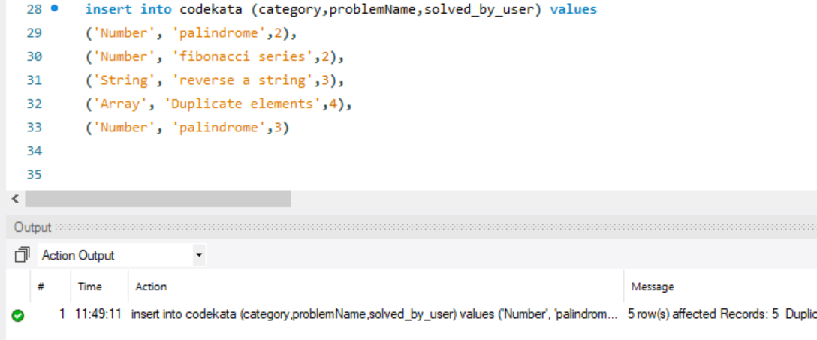

Attendance:
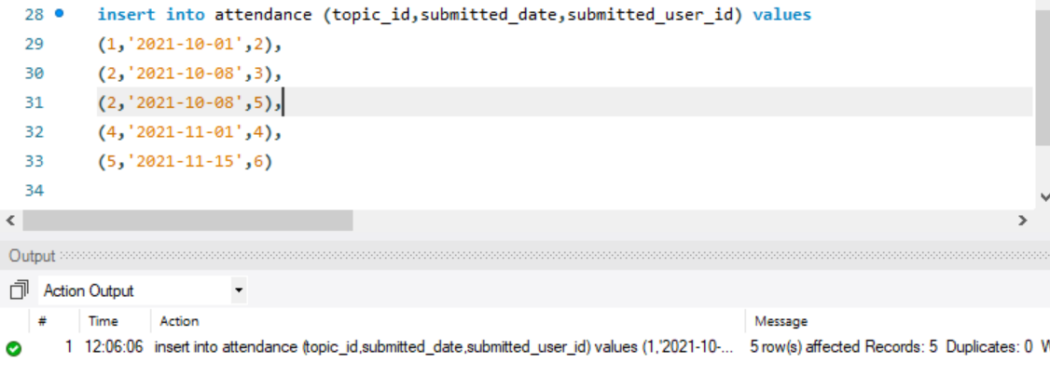
Topics:
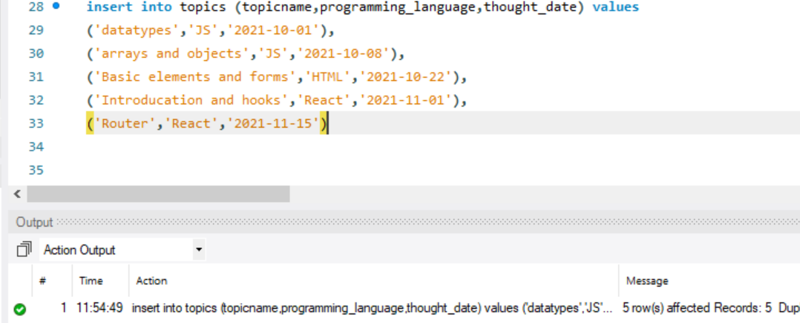

Tasks:
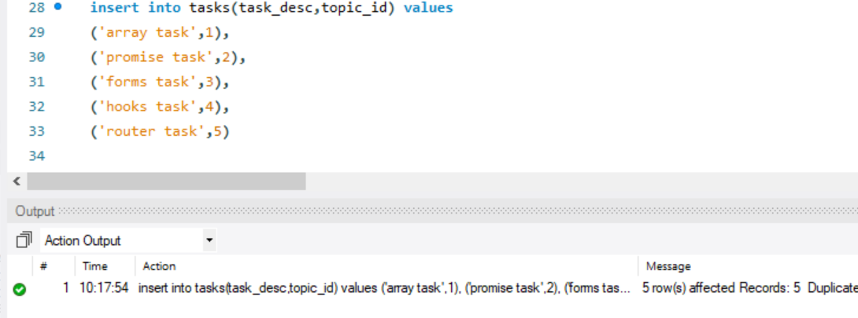

Company drives:
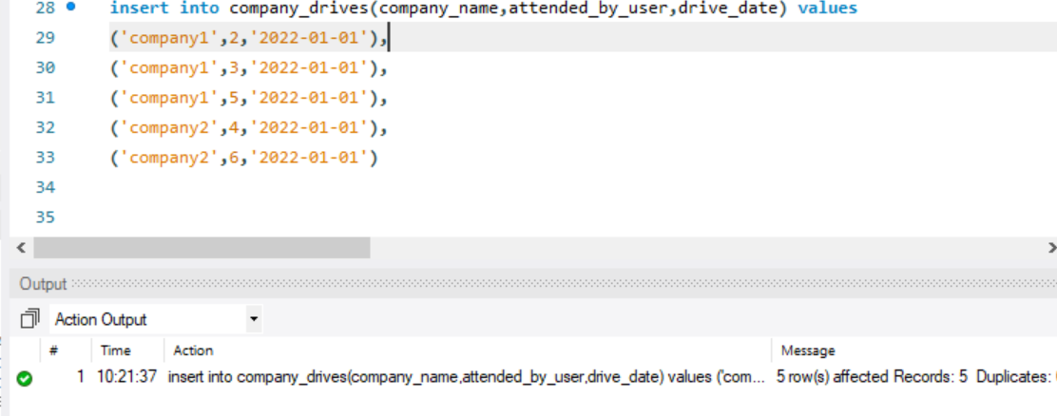

Mentors:
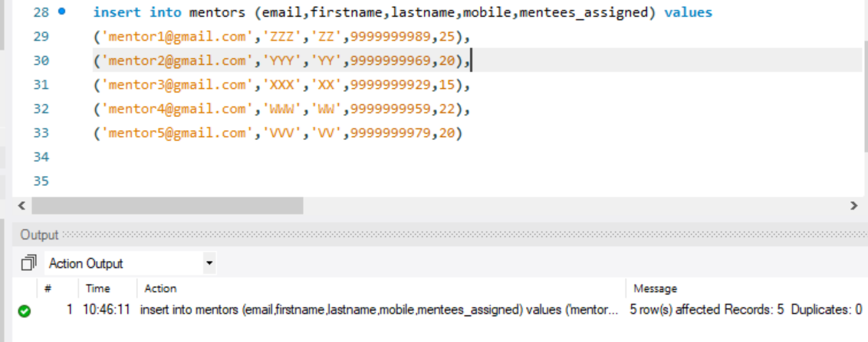

Student activated courses:
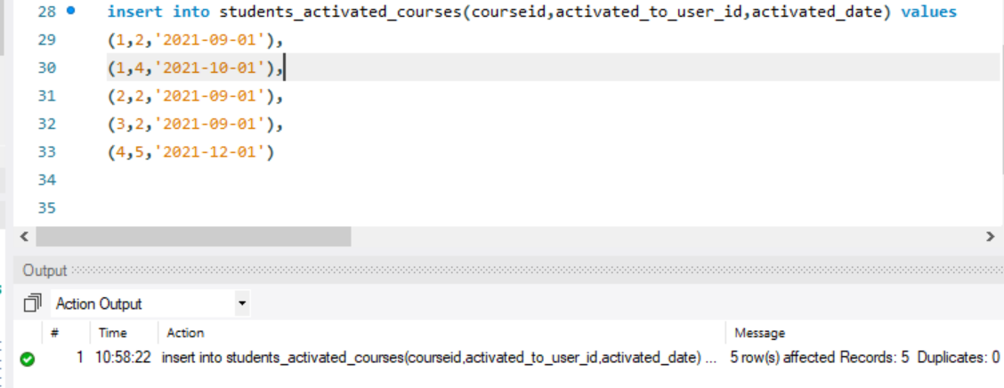

Courses;
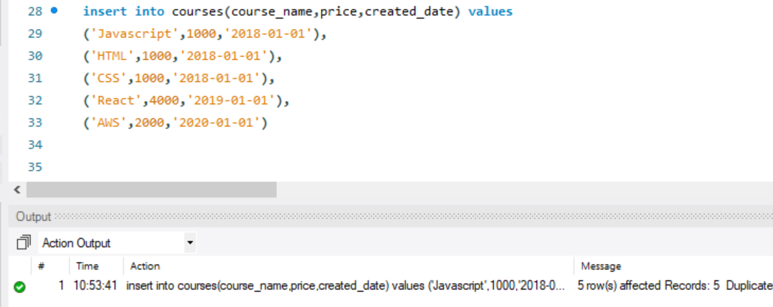

3. get number problems solved in codekata by combining the users.
Answer:
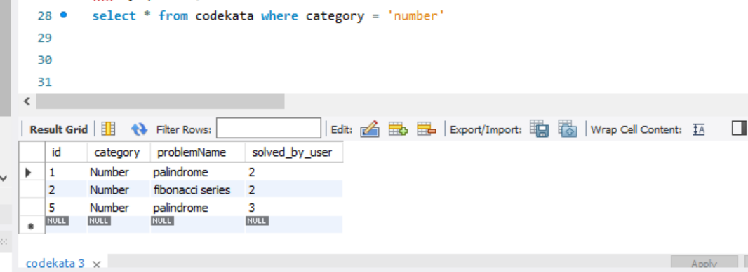

4. display the no of company drives attended by a user.
Answer:
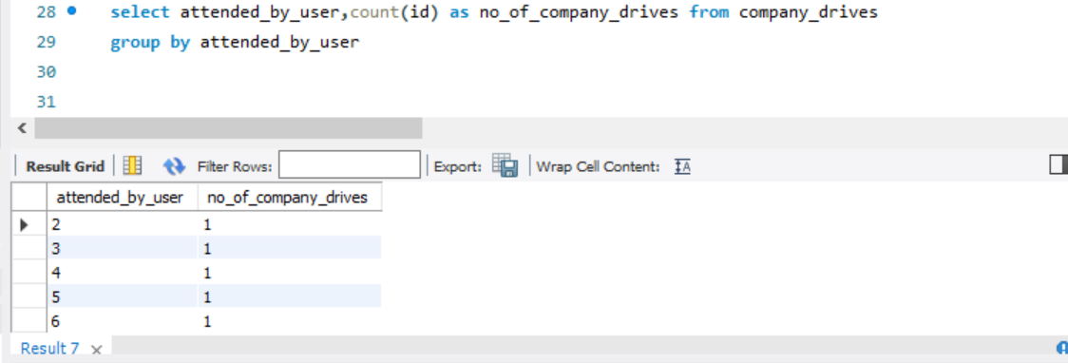

5. combine and display students_activated_courses and courses for a specific user groping them based on the course
Answer:
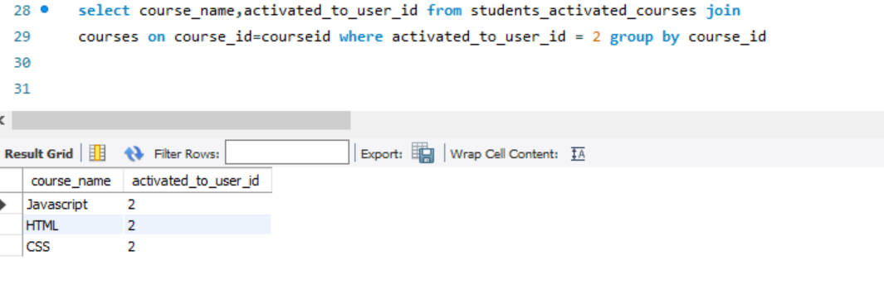
6. list all the mentors
Answer:
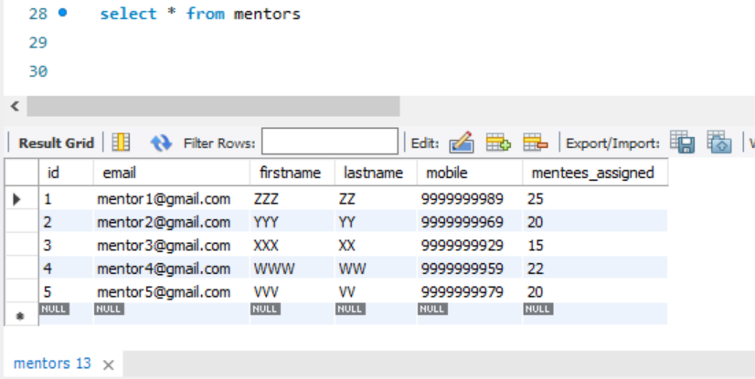

7. list the number of students that are assigned for a mentor
Answer:
